Voice Dial Peers
In order to understand the concept of dial peers, it is important to understand call legs. A voice call over a packet network is segmented into discrete call legs. A call leg is simply a logical connection between two voice gateways over an IP, Frame Relay or Asynchronous Transfer Mode (ATM) network, for example; between a voice gateway and an IP Telephony device, such as Cisco Unified Communications Manager or even a SIP Server; or between two voice termination endpoints, such as between a phone or PBX and a voice gateway. As an example, consider the following network diagram:
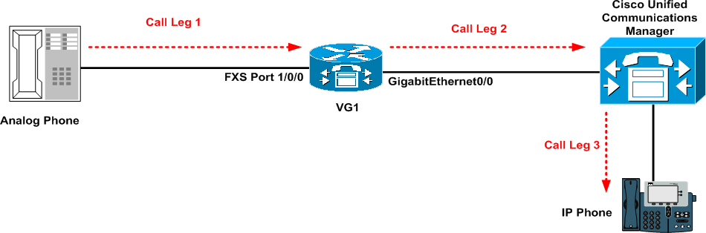
In the diagram above, the voice gateway (VG1) is connected to both an analog telephone via an FXS port and the Cisco Unified Communications Manager (via an IP connection). The analog telephone places a call to an IP phone registered to the CUCM server. The first call leg is therefore between the analog telephone and the voice gateway. Because the call is originating from the connected phone, the voice gateway is referred to as the Originating Gateway.
When the gateway receives the digits, it places an outbound call and sends the digits to the intended destination, which is the CUCM server. This is the second call leg. Given that the CUCM server is the final gateway before the endpoint, it is referred to as the TG. The CUCM server in turn then forwards the call to the IP phone. This is the third call leg.
Let's take a look at another example, which is based on the following diagram:
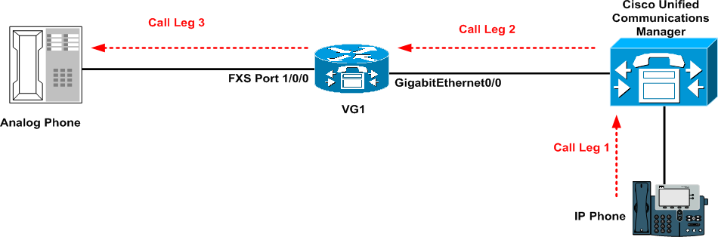
In this example, the call flow is reversed. The IP phone initiates a call to the analog phone. The first call leg therefore resides between the IP phone and its gateway, the Cisco Unified Communications Server. The CUCM analyses the digits and forwards them to the remote gateway (VG1). This is the second call leg. Based on this call flow, the CUCM server is considered the Originating Gateway (OG).
When the VG1 receives the digits, it forwards them to the connected analog phone. Given that this is the last point before the endpoint, VG1 is considered the Terminating Gateway. This is the third and final call leg.
It is important to keep in mind that the terms Originating Gateway (OG) and Terminating Gateway (TG) are dependent on the source to destination direction of the call. A voice gateway can be the OG in one call and the TG in another. While the gateway will either be the OG or the TG, it is important to know that the gateway can also be both the OG and TG. This concept is referred to as hair-pinning and is illustrated in the following diagram:
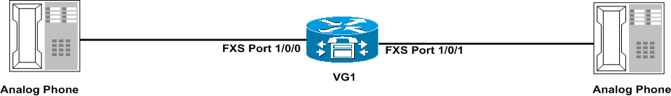
Based on the diagram above, calls from either analog phone will originate and terminate on the same device (VG1). In Cisco voice gateways, hair-pinning is only supported for PSTN (POTS)-to-PSTN (POTS) calls; it is not supported for VoIP-to-VoIP calls.
Call legs are then configured in the router as dial peer statements. In essence, a dial-peer is associated with each call leg. The matching process for a dial peer will vary depending on whether it is an inbound dial peer (i.e. it is matching incoming calls) or an outbound dial peer (i.e. it is matching outgoing calls).
In addition to this, the matching process for inbound and outbound dial peers will vary depending on whether Direct Inward Dialing (DID), also referred to as Direct Dial-In (DDI) in Europe is configured. Inbound and outbound dial peer matching with and without DID, or DDI, is described in the following section:
Inbound Dial Peer Matching without Direct Inward Dial
Calls that are coming to a gateway will match a dial peer based on the source, not destination, of the call. The steps for matching inbound dial peers without DID are as follows:
1. Match the called number (DNIS) to the incoming called number that is matched on the dial peer. This is a common method of matching the inbound dial peer and is implemented by issuing the incoming called-number [pattern] dial peer configuration command.
2. Match the calling number (ANI) to the answer address that is configured on the dial peer. This is performed by issuing the answer-address [pattern] dial peer configuration command, which allows a dial peer to answer a call based on the source (calling) number.
3. Match the calling number (ANI) to the destination pattern that is configured on the dial peer. This is performed by issuing the destination-pattern [pattern] dial peer configuration command. This configuration is the most commonly implemented configuration because it allows a single dial peer and pattern for both inbound and outbound matching.
4. Match the voice port that is associated with the call to the port that is configured on the dial peer. This step is only applicable to calls that originate on POTS not VoIP dial peers and is performed via the port dial peer configuration command.
5. Match the default dial peer. The default dial peer (dial peer 0) is matched only when no other inbound dial peer is found. This is a fail-safe mechanism integrated into Cisco voice gateways. In the Cisco AS5xxx voice gateways, an inbound dial peer must be configured for a call to be processed as a voice call because these devices support both modem and voice termination. If an inbound dial peer, the AS5xxx series gateway will process the received call as a modem call, which may have undesirable consequences. On Cisco IOS voice gateways, an inbound dial peer is recommended; however, it is not mandatory to have one.
NOTE: The default dial peer and its call parameters cannot be modified. This dial peer may be a POTS dial peer or a voice-network dial peer, and is always referred to as dial peer 0 or pid:0.

Dial peer 0 (pid:0) has a default configuration that cannot be changed. The default dial peer cannot negotiate non-default capabilities, services, and applications such as:

- Non-default Voice-Network capabilities, such as DTMF Relay and VAD
- Direct Inward Dial (DID)
- (Tool Command Language) TCL Applications

The default dial peer for inbound VoIP peers has the following default configuration:

- It supports any codec
- It has VAD enabled
- It provides no Resource Reservation Protocol (RSVP) support
- It provides fax-rate voice support

The default dial peer for inbound POTS peers has the following default configuration:

- It does not support Interactive Voice Response (IVR) applications

The following diagram illustrates the operation of an inbound POTS call without DID on a voice gateway that is connected to the PSTN via a T1 and two analog phones via FXS ports:
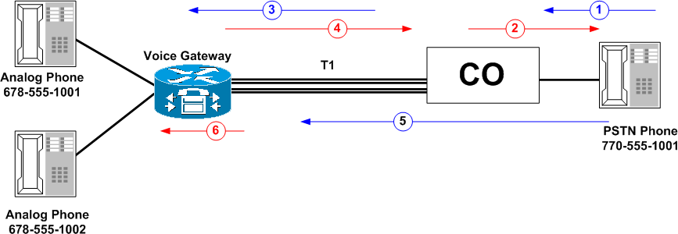
In step 1, the calling party on the PSTN (770-555-1001) picks up the telephone handset in preparation for a call to 678-555-1002. The calling party then receives dial tone from the CO, as illustrated in step 2 of the diagram above.
Once the calling party has received dial tone, the subscriber enters the digits, as illustrated in step 3. The DNIS (called party) information is then sent from the CO to the voice gateway, as illustrated in step 4 of the diagram above.
The voice gateway receives this information but does not use it to route the call. Instead, the voice gateway plays a second dial tone, asking the calling party for more information. The calling party then enters the specific extension they wish to call, which is 1002. This is illustrated in step 5 of the diagram above.
NOTE: It is important to know that whether the digits are dialed with irregular intervals by humans or in a regular fashion by telephony equipment sending the pre-collected digits, dial peer matching is done digit-by-digit. In other words, the gateway will attempt to match a dial peer based on configured destination patterns, after each digit is received.
As soon as a destination pattern is fully matched, the call is routed. In this case, the call is routed to 678-555-1002 as illustrated in step 5. This process is called two-stage dialing.
Outbound Dial Peer Matching without Direct Inward Dial
The outbound dial peer matching process is straightforward. In essence, all configured dial peers on the voice gateway, i.e. both POTS and voice-network dial peers, are considered and the most specific match is used to forward the digits to their intended destination. The steps for outbound dial peer matching when DID is not configured or enabled are as follows:
1. Match the called number to the destination pattern configured on the dial peer via the destination-pattern [pattern] dial peer configuration command. On POTS dial peers, the port command is then used to forward digits to their destination using the specified port, and on voice-network dial peers, the session target command is used to forward digits.
2. If multiple dial peers exist, the gateway matches the called number to the one with the lowest preference. Dial peer preference is configured via the preference [number] dial peer configuration command. Dial peer preference will be described in detail later in this guide.
3. If all dial peers have the same preference, the randomly select one.
Direct Inward Dial (DID)
Before we learn about inbound and outbound dial peer matching when Direct Inward Dial (DID) is enabled, it is important to understand what DID is. Direct Inward Dial (DID), or Direct Dial-In (DDI), as it is called in Europe and other parts of the world, is a service offered by telephone companies that enables callers to dial directly to an extension on a PBX or voice gateway without the assistance of an operator or automated call attendant. DID allows voice customers to have many private numbers allocated to the business and at the same time reduce the actual number of lines required to carry those numbers.
DID makes use of DID trunks, which are telephone company provided trunks that forward only the last three to five digits of a telephone number to the PBX or voice gateway. If for example, a company has phones extensions 555-1000 to 555-1999, and a caller dials 555-1234, and the telephone company was only sending the company the last four digits, the local CO would forward 1234 to the PBX or voice gateway. The PBX or voice gateway would then ring extension 1234. This entire process is transparent to the caller.
The telephone company uses the DNIS, which sends the called number from the local CO to the PBX or voice gateway. In addition to this, the telephone company also provides Automatic Number Identification (ANI) that delivers the calling-number, or the number of the call originator, for outbound calls placed from the customer PBX or voice gateway. ANI is also referred to as Calling Line Identification (CLID). These two digits make it possible to route both inbound and outbound calls. DID operation is illustrated in the following diagram:
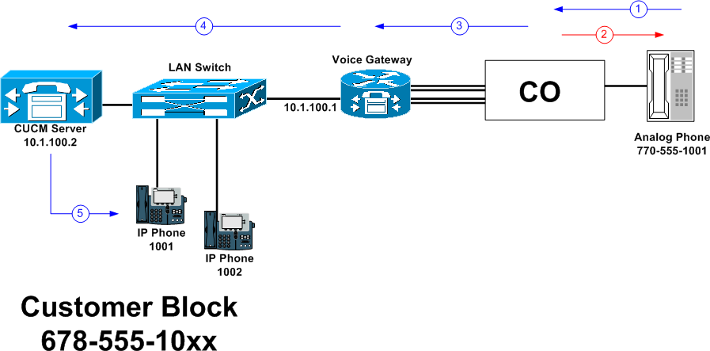
The diagram above illustrates a customer who has been assigned the 678-555-1000 to 678-555-1099 range from their telephone provider. The customer is using DID service and the telephone provider is only sending the last four digits of the called number to the customer.
The PSTN calling party, 770-555-1001, picks up the phone with the intention of calling 678-555-1001, as illustrated in step 1. The local CO provides the calling party dial tone, as illustrated in step 2, and they proceed and dial the number.
The CO switch sends the voice gateway a setup message containing all the digits necessary to fully route the call. Based on this example, the digits 1001 are sent to the voice gateway as illustrated in step 3.
Because DID is configured on the inbound POTS dial peer connected to the PSTN, the voice gateway does not present a dial tone to the caller and does not collect digits. Instead, it forwards the call directly to the configured destination, which happens to be the CUCM server. Digits are collected in-band. This is called one-stage dialing and the following configuration illustrates how the configuration may be performed based on the previous diagram. Keep in mind, however, that only the relevant portions of the configuration are included in this output:
interface GigabitEthernet0/0
description 'Voice Gateway LAN interface connected to CUCM Server"
ip address 10.8.100.1 255.255.255.0
!
dial-peer voice 1 pots
description DID Range 1000 To 1099 Inbound from PSTN
incoming called-number 10..
direct-inward-dial
!
dial-peer voice 2 voip
description DID Range 1000 To 1099 To CUCM Server 10.1.100.2
destination-pattern 10..
session target ipv4:10.1.100.2
dtmf-relay h245-alphanumeric
In the configuration provided above, the POTS dial peer is an inbound dial peer that matches a DNIS between 1000 and 1099 based on the incoming called-number 10.. configuration statement. This dial peer is also configured for DID via the direct-inward-dial dial peer configuration command.
VoIP dial peer 2 forwards all digits within the range 1000 to 1099 to the CUCM server based on the destination-pattern 10.. and session target ipv4:10.1.100.2 configuration command statements. Dial peer and destination pattern configuration will be described in detail later in this guide; the main emphasis at this point should be to understand basic DID operation.
Inbound Dial Peer Matching with Direct Inward Dial
Inbound dial peer matching when using DID is the same as that used when DID is not configured. Therefore, for brevity, these steps will not be described again. Refer to the previous section on inbound dial peer matching without DID if you do not recall the steps described.
Outbound Dial Peer Matching with Direct Inward Dial
Outbound dial peer matching when using DID is the same as that used when DID is not configured. Therefore, for brevity, these steps will not be described again. Refer to the previous section on outbound dial peer matching without DID if you do not recall the steps described.
NOTE: It is important to understand that DID does not affect the dial peer selection process, but rather how the actual match is made. Without DID, as the caller enters digits, the digits are compared to configured destination patters and as soon as a complete match is made, the call is routed. However, with DID, the entire DNIS is used to match the outbound dial peer.
Dial Peer Types
Cisco voice gateways support several different types of dial peers. These dial peers are configured via the dial-peer voice [tag] [type] global configuration command. Although dial peer configuration will be described in detail later in this guide, the following output illustrates the different types of dial peers that can be configured on the voice gateway. Keep in mind, however, that the types will vary based on the version of software that the gateway is running, as well as the type of Cisco IOS gateway the command is issued on. The following output is based on a Cisco 3800 ISR router running Cisco IOS version 12.4:
R1(config)#dial-peer voice 1 ?
mmoip Multi Media Over IP
pots Telephony
voatm Voice over ATM
vofr Voice over Frame Relay
voip Voice over IP
The mmoip option is used for a dial peer that will forward packet to a multimedia mail peer that uses IP encapsulation on the IP backbone. MMOIP is beyond the scope of the CVOICE.
The pots option is used for a POTS peer that uses VoIP encapsulation on the IP backbone. POTS dial peers are analog or digital connections to a telephone, fax machine, PBX, or the PSTN. The configuration of POTS dial peers and ports will be described in detail later in this guide.
The voatm option specifies that this is a Voice over Asynchronous Trasnfer Mode (ATM) dial peer that uses real-time AAL5 voice encapsulation on the ATM backbone network. VoATM is beyond the scope of the CVOICE.
The vofr option specifies that this is a VoFR dial peer that uses Frame Relay Fragmentation 11, or FRF.11, encapsulation on the Frame Relay backbone network. While Frame Relay is a prevalent and commonly used Layer 2 technology, VoFR is beyond the scope of the CVOICE.
Finally, the voip option indicates that this is a Voice over IP peer that uses voice encapsulation on the POTS network. Although VoIP dial peers support both IPv4 and IPv6, the current CVOICE configurations and requirements will be restricted only to IPv4 only.
Voice dial peers are divided into two main categories: POTS and voice-network. All dial peers (e.g. VoIP, VoFR, etc) that are not POTS dial peers are referred to as voice-network dial peers. In order to reinforce the concepts we have just learned, we will use the following diagram:
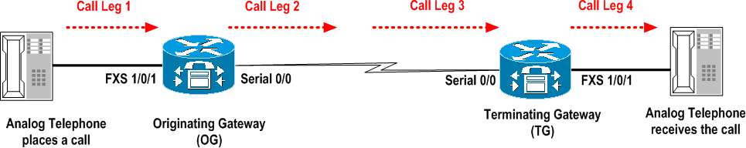
The diagram above illustrates the call legs in a call from one analog phone to another, as indicated by the direction of the arrows. In this example, the call setup process is as follows:
1. The POTS call arrives at the OG via the FXS 1/0/1 port. This call matches an inbound POTS dial-peer, because the port is connected to an analog device. After the OG associates the incoming call to an inbound POTS dial-peer, it creates an inbound POTS call leg and assigns it a Call ID. This is the first call leg.
2. The OG then uses the received dialed string to match the outbound voice-network dial-peer, which will be destined for the TG over an IP connection. The OG creates an outbound voice-network call leg and assigns it a Call ID. This is the second call leg.
3. The voice-network call request arrives at the TG. This request matches an inbound dial peer. If there are no inbound dial peers configured, the request matches the default dial peer. After the TG associates the incoming call to an inbound voice-network dial peer, or the default dial peer (dial peer 0), it creates the inbound voice-network call leg and assigns it a Call ID. This is the third call leg.
4. The TG then uses the dialed string (the string dialed by the originating party) to match the outbound POTS dial-peer. After it associates the incoming call setup to the outbound POTS dial peer, it creates an outbound POTS call leg, assigns it a Call ID, and terminates the call. This is the fourth and final call leg. The call is now complete.
The show dial-peer voice summary command can be issued on Cisco IOS voice gateways to view the currently configured voice dial peers. The following output illustrates the dial peers configured on a Cisco IOS voice gateway:
R1#show dial-peer voice summary
dial-peer hunt 0
AD PRE PASS OUT
TAG TYPE MIN OPER PREFIX DEST-PATTERN FER THRU SESS-TARGET STAT PORT
1001 pots up up [1-9]....... 0 up 1/0:1
1002 pots up up [1-9]....... 0 up 2/0:1
2001 voip up up 6[0,3].. 0 syst ipv4:10.1.254.1
2002 voip up up 6[1,2].. 0 syst ipv4:10.1.254.2
In the output illustrated above, R1 is configured with four dial peers. Two dial peers, 1001 and 1002, are POTS dial peers and are connected to the PSTN. These dial peers forward digits to port 1/0:1 and 2/0:1, respectively. Dial peers 2001 and 2002, on the other hand, are VoIP dial peers, which point to remote gateways 10.1.254.1 and 10.1.254.2, respectively. The destination patterns illustrated for all four dial peers will be described in detail later in this chapter.

